Model Performance Test

|  |  |
| --- | --- |
| Date | 26 JUNE 2025 |
| Team ID | LTVIP2025TMID31649 |
| Project Name | Lease Management |
| Maximum Marks |  |

**Model Performance Testing:**

# Trigger Error:

Validation logic is applied when incorrect or mismatched data is entered during lease record creation (e.g. lease start date after end date).

System throws an error and prevents record creation.

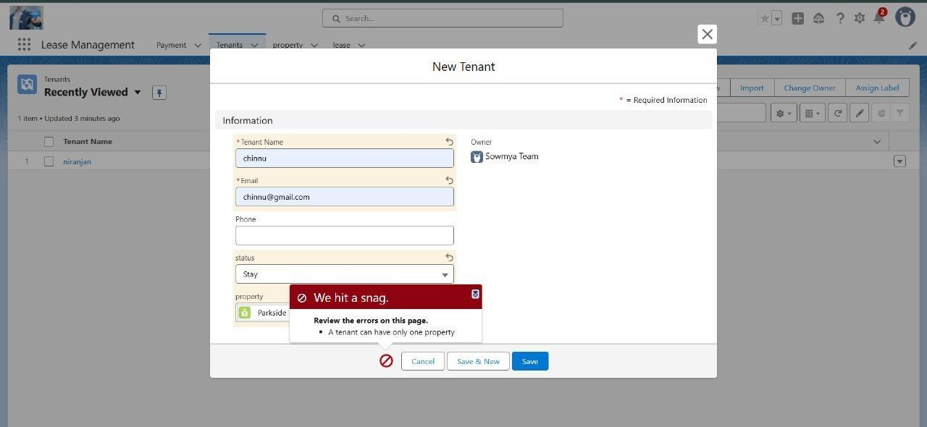

# Validation Check – Dates Different & End Date is Less:

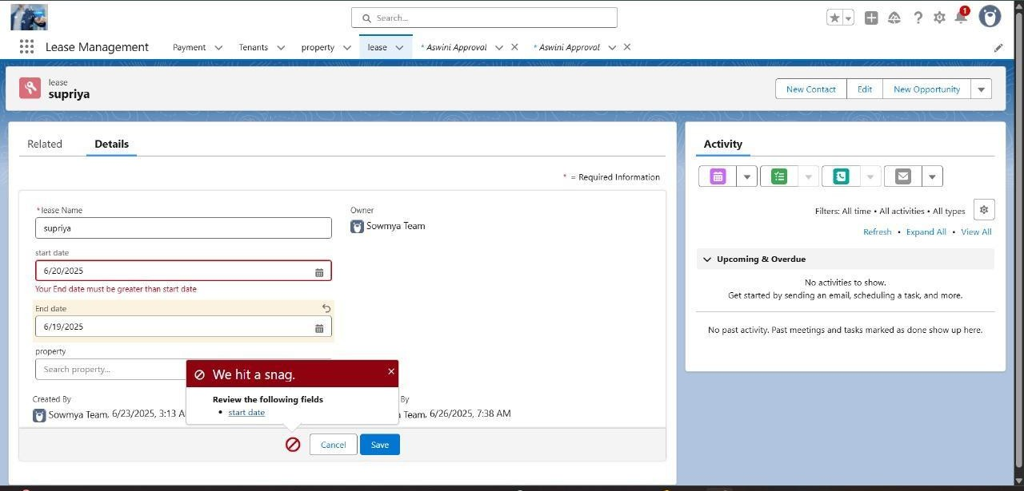Business rule checks that lease End Date must be after Start Date. If End Date is lesser, system shows validation error and restricts submission.

# Validation Rule Check – Dates Same:

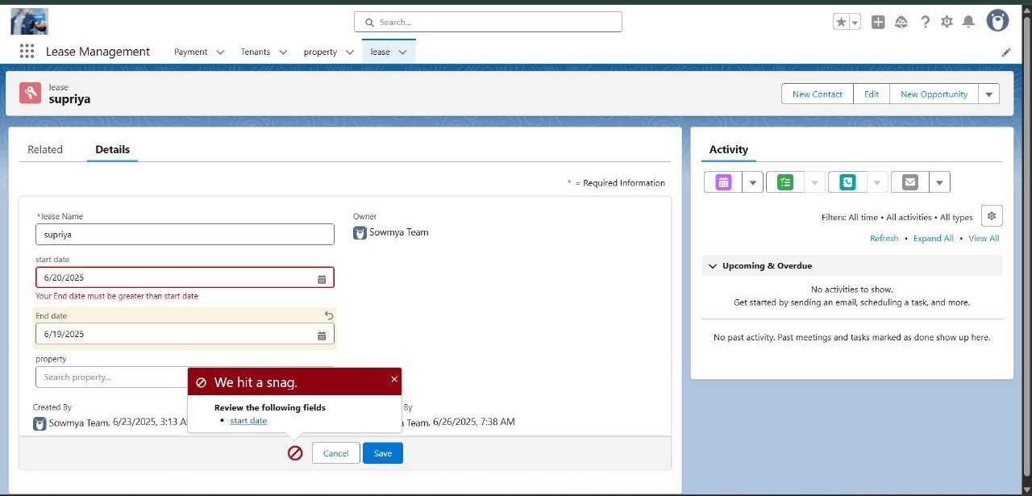A validation rule ensures Start Date and End Date cannot be the same. System flags this as invalid and prompts user to revise inputs.

# Flow Testing – Payment Update:

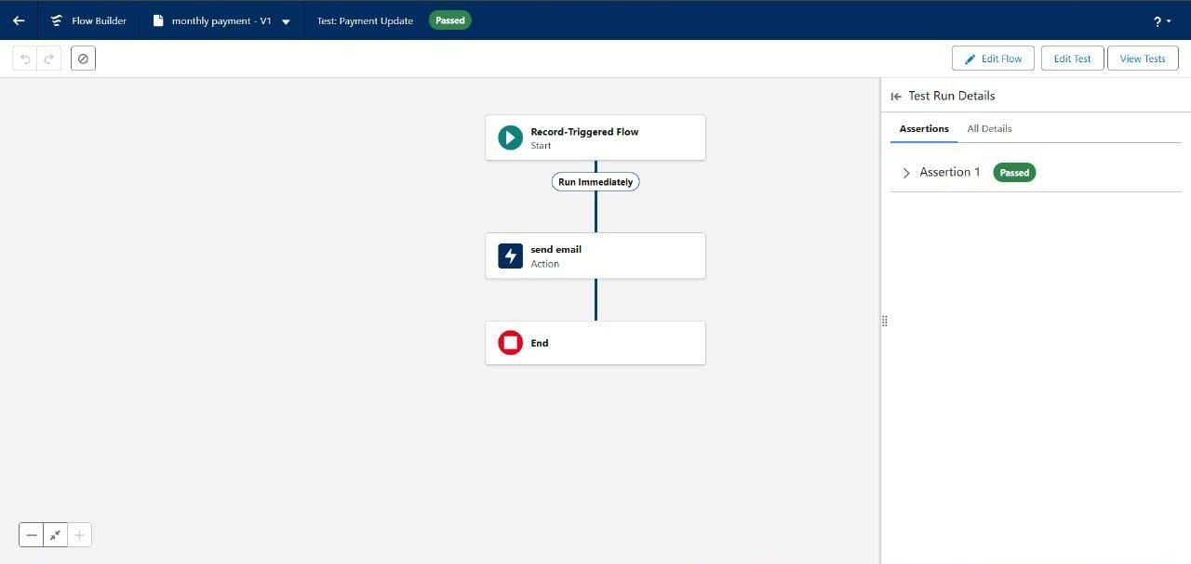Flow automation updates Payment Status automatically upon payment log entry. Test confirms the status updates accurately and triggers notification.